# Online Course Reservation System

*STATE DIAGRAM*

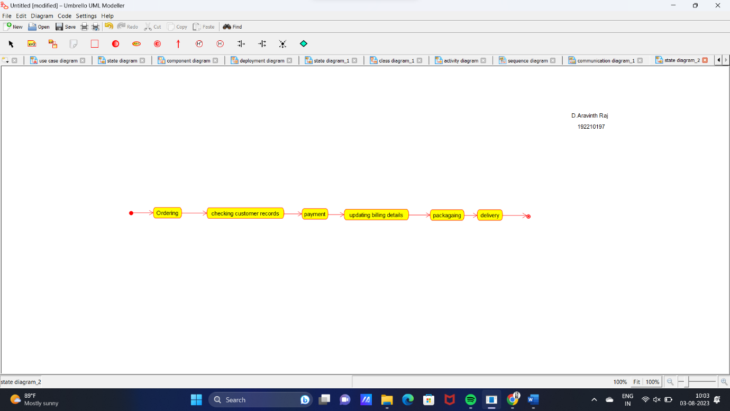

*DEPLOYMENT DIAGRAM*

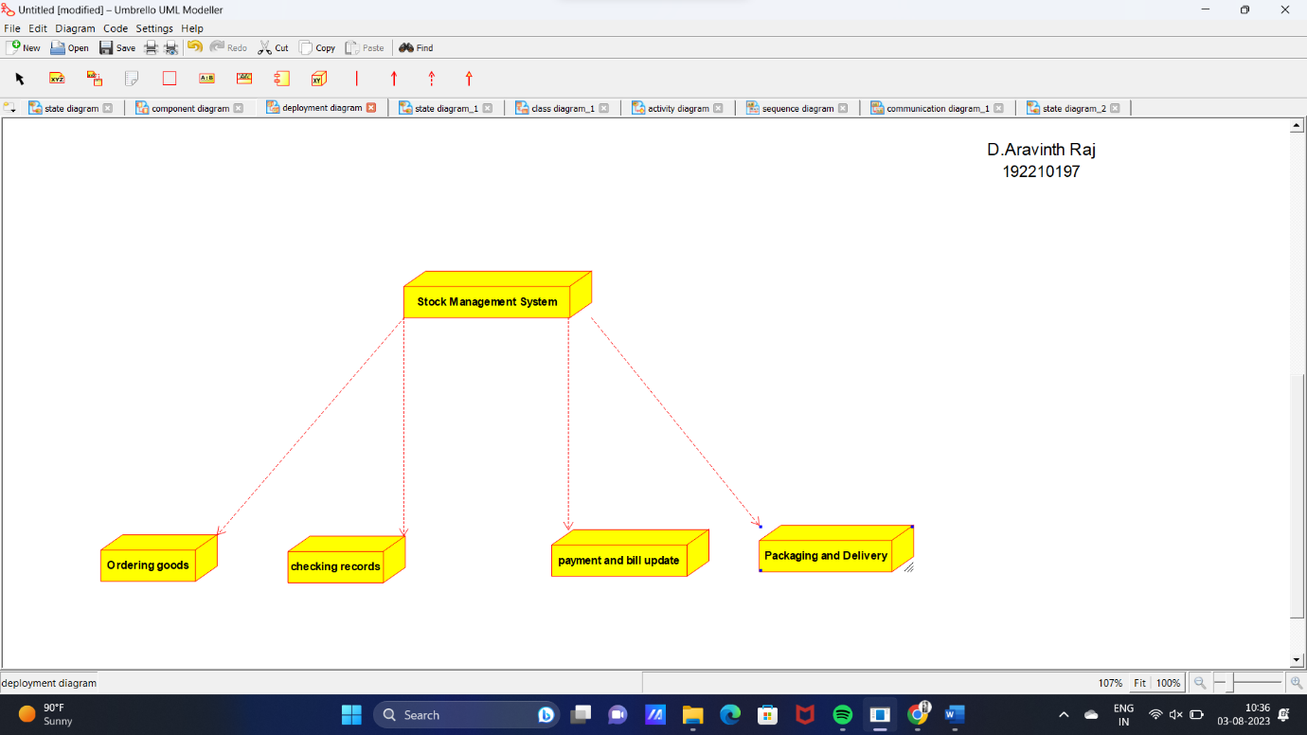

*COMPONENT DIAGRAM*

